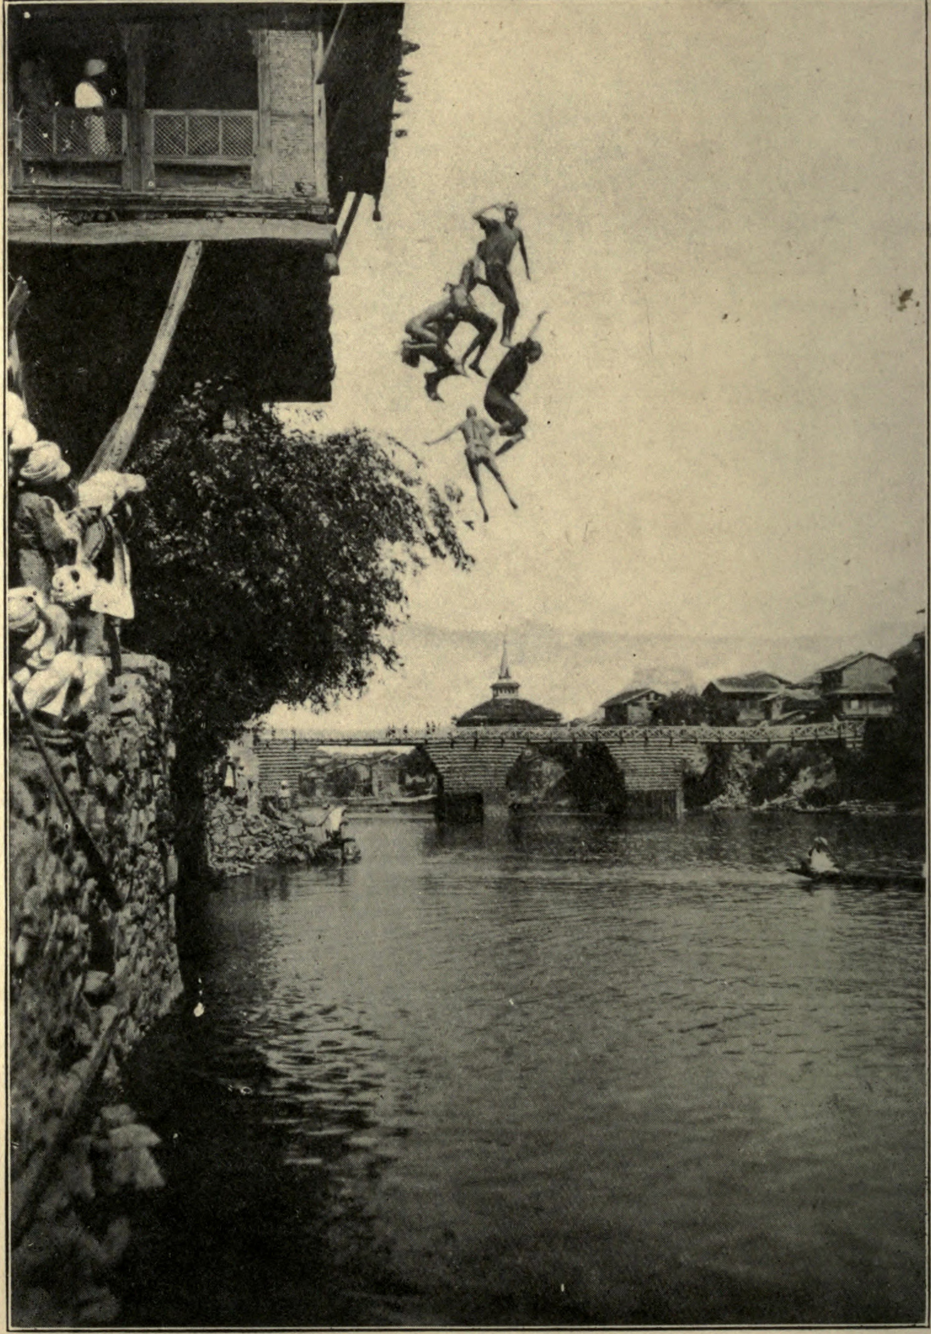

A Spalsh-Dash into a river from the   
school

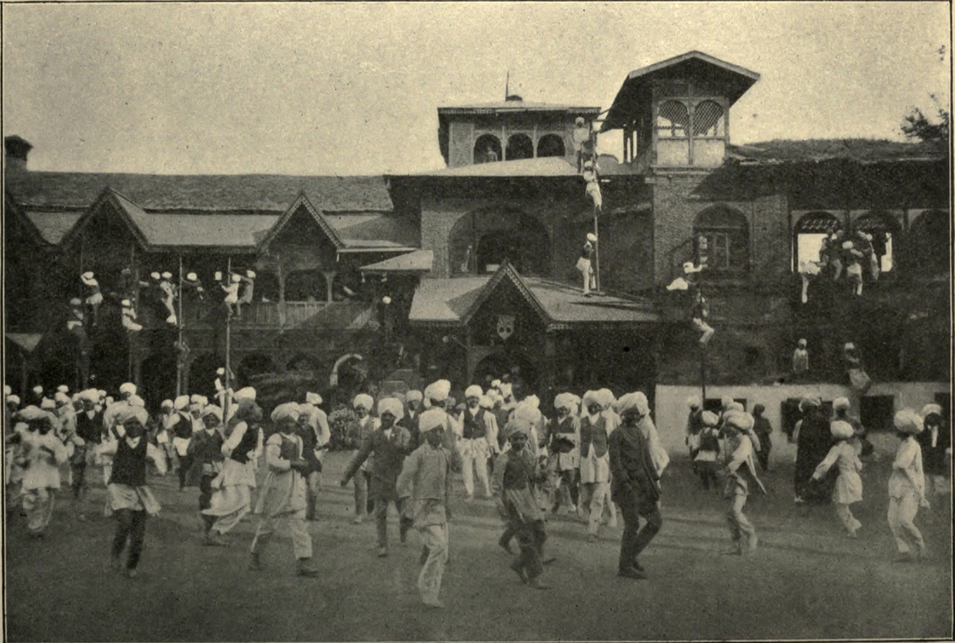

Helter-skelter:

School cleared in twenty five seconds

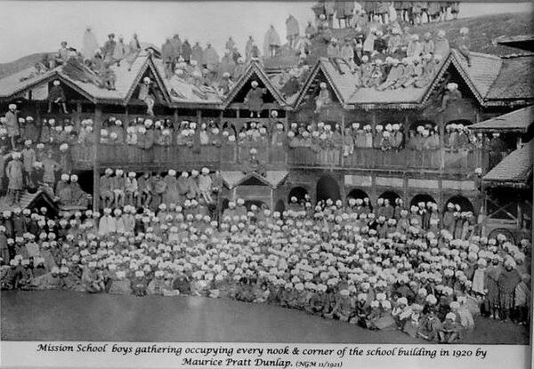

School Gathering